**DAILY ONLINE ACTIVITIES SUMMARY**

|  |  |  |  |  |  |  |  |  |
| --- | --- | --- | --- | --- | --- | --- | --- | --- |
| **Date:** | **29-05-2020** | | | | | **Name:** | **Huda Sultana** | |
| **Sem & Sec** | **8 A** | | | | | **USN:** | **4AL16CS039** | |
| **Online Test Summary** | | | | | | | | |
| **Subject** | | **BDA** | | | | | | |
| **Max. Marks** | | **30** | | **Score** | | | **21** | |
| **Certification Course Summary** | | | | | | | | |
| **Course** | **AWS Cloud Practitioner Essentials** | | | | | | | |
| **Certificate Provider** | | | **AWS** | | **Duration** | | | **6 hours** |
| **Coding Challenges** | | | | | | | | |
| **Problem Statement:**   1. **Write a C Program to generate first N Armstrong Numbers.** | | | | | | | | |
| **Status: Solved** | | | | | | | | |
| **Uploaded the report in Github** | | | | | **Yes** | | | |
| **If yes Repository name** | | | | | **Hudasulltana/online_coding** | | | |
| **Uploaded the report in slack** | | | | | **Yes** | | | |

Online Test Details: (Attach the snapshot and briefly write the report for the same)

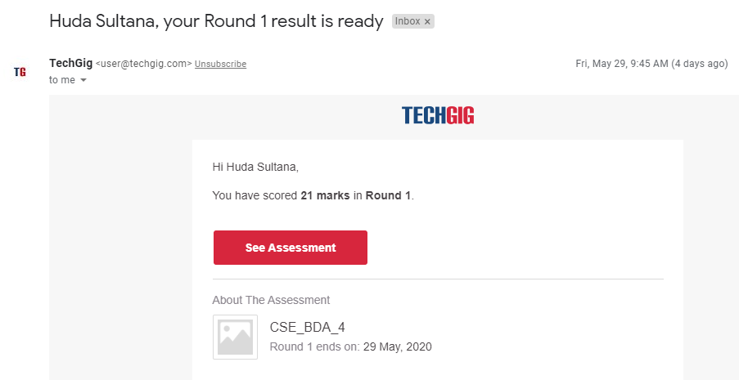

Certification Course Details: (Attach the snapshot and briefly write the report for the same)

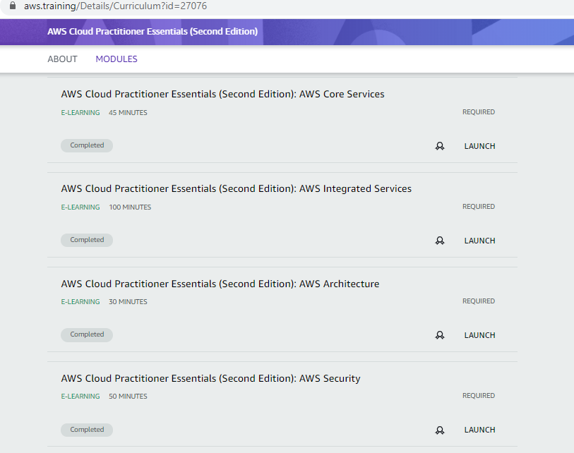

Coding Challenges Details: (Attach the snapshot and briefly write the report for the same)

**PROGRAM 1 .**

**//Write a C Program to generate first N Armstrong Numbers.**

**#include<stdio.h>**

**void main()**

**{**

**int n,copy=152,remainder,sum,x;**

**printf("Enter a number\n");**

**scanf("%d",&n);**

**//starting copy from 152 as we know 153 is an armstron no**

**printf("Armstrong numbers are\n");**

**while(n!=0)**

**{**

**copy++;**

**x=copy;**

**sum=0;**

**//printf("\n2nd copy = %d ",copy);**

**while(copy!=0)**

**{**

**remainder=copy%10;**

**sum=sum+remainder*remainder*remainder;**

**copy=copy/10;**

**}**

**if(sum==x)**

**{**

**printf("\n%d",x);**

**n--;**

**}**

**copy=x;**

**}**

**}**